***Lincoln Hospital District #3 and NBMC Antibiogram: 2018*-2020 Data***

***(2018 only contains 6 mos of data due to lab remodel)***

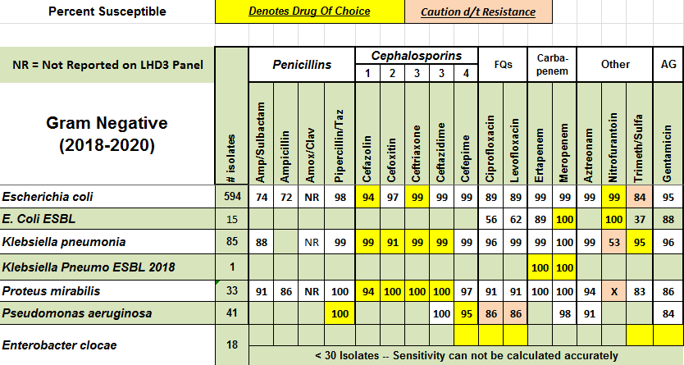

|  |  |  |  |  |  |  |
| --- | --- | --- | --- | --- | --- | --- |
| **LHD3 MDRO Patterns** | **2020** | **2019** | **2018\*** | **2017** | **2016** | **2015** |
| **MRSA%** | **34%** | **41%** | **37.5%** | **37%** | **33%** | **47%** |
| **ESBL (TOTAL)** | **6** | **7** | **4** | **11** | **11** | **6** |
| **VRE (TOTAL)** | **0/25** | **1/35** | **0/17** | **2/34** | **2/30** | **0/35** |
| **CRE (TOTAL)** | **0** | **0** | **0** | **0** | **0** | **0** |

